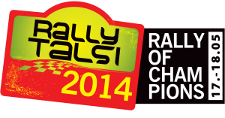

&
VĒSTURISKO AUTOMOBIĻU REGULARITĀTES RALLIJS
HISTORICAL REGULARITY RALLY
Pietiekuma forma Entry form

Automašīnas klase/Competition class(historic) …………………………..
Pilots/Driver(Name, Surname) …………………………………
Valsts/Country ………………………….
Licences tips/License type(national, international) …………………………………..
Licences Nr./License No …………………………….
Mob.tel./Mobile phone …………………………….
E-pasts/email ……………………………..
Stūrmanis/Co-driver(Name, Surname) ……………………………………
Valsts/Country ………………………….
Licences tips/License type(national, international) …………………………………..
Licences Nr./License No …………………………….
Mob.tel./Mobile phone …………………………….
E-pasts/email ……………………………..
Automobiļa marka&modelis/Car make&model ……………………………..
Automobiļa reģistrācijas Nr./Car registration plate No. ……………………………..
FIA pases Nr./FIA passport No ……………………………….

I want to book accommodation from … 05.2014 till … 05.2014 for …. persons. Double room for 2 persons cost 30,00 Euro (+ 5,00 Euro breakfast per person)

Send to: agris.stanevics@gmail.com
Phone: +371 29233599

